**Lab 1 Task 3**

**Introduction**

Creating an Application which will display the description of notable entities (e.g., people, places, things) that match specific criteria.

**Objectives:**

To implement the below provided tasks

1. HTML
2. CSS
3. Bootstrap
4. Responsive Web Design
5. JavaScript
6. AJAX
7. Angular

**Requirements:**

1. WebStorm
2. Node JS
3. Angular CLI

**Creating API Key**

For this task we have to create an API Key for Google Knowledge Graph API.

We can do this visiting the [**https://developers.google.com/knowledge-graph/**](https://developers.google.com/knowledge-graph/)and follow the below steps

1. **Click on use the setup tool**

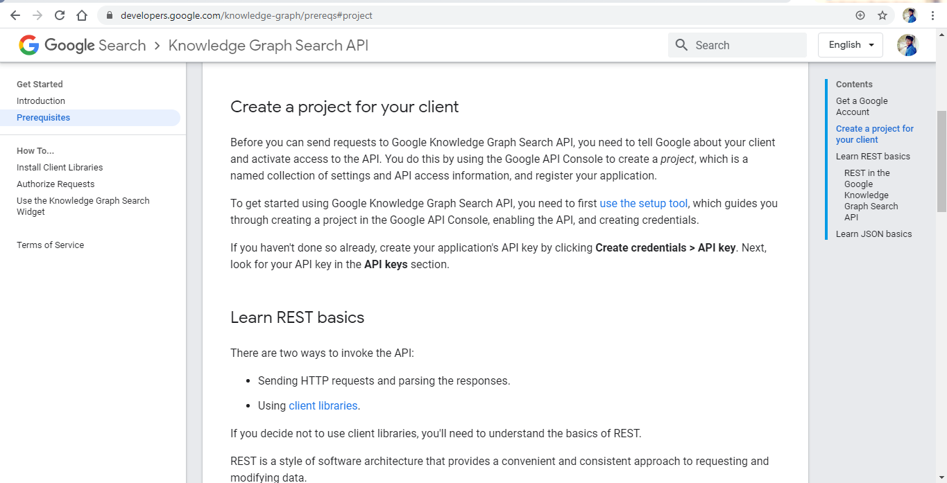

1. **Click on Create a Project**

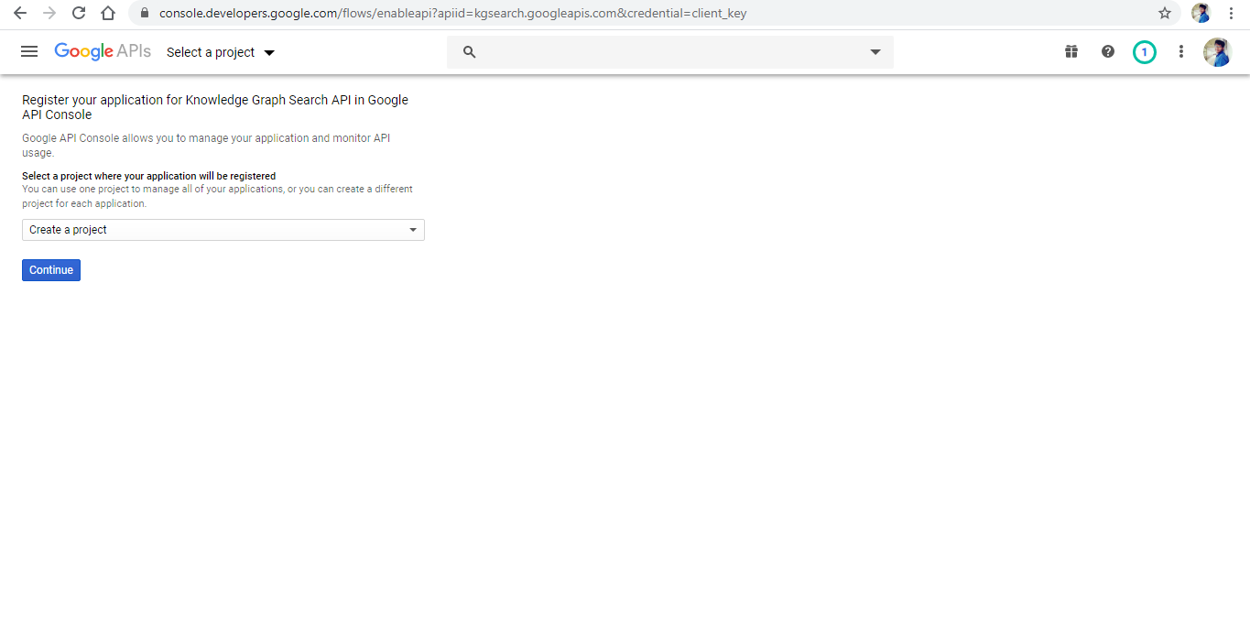

1. **Click on Go to Credentials**

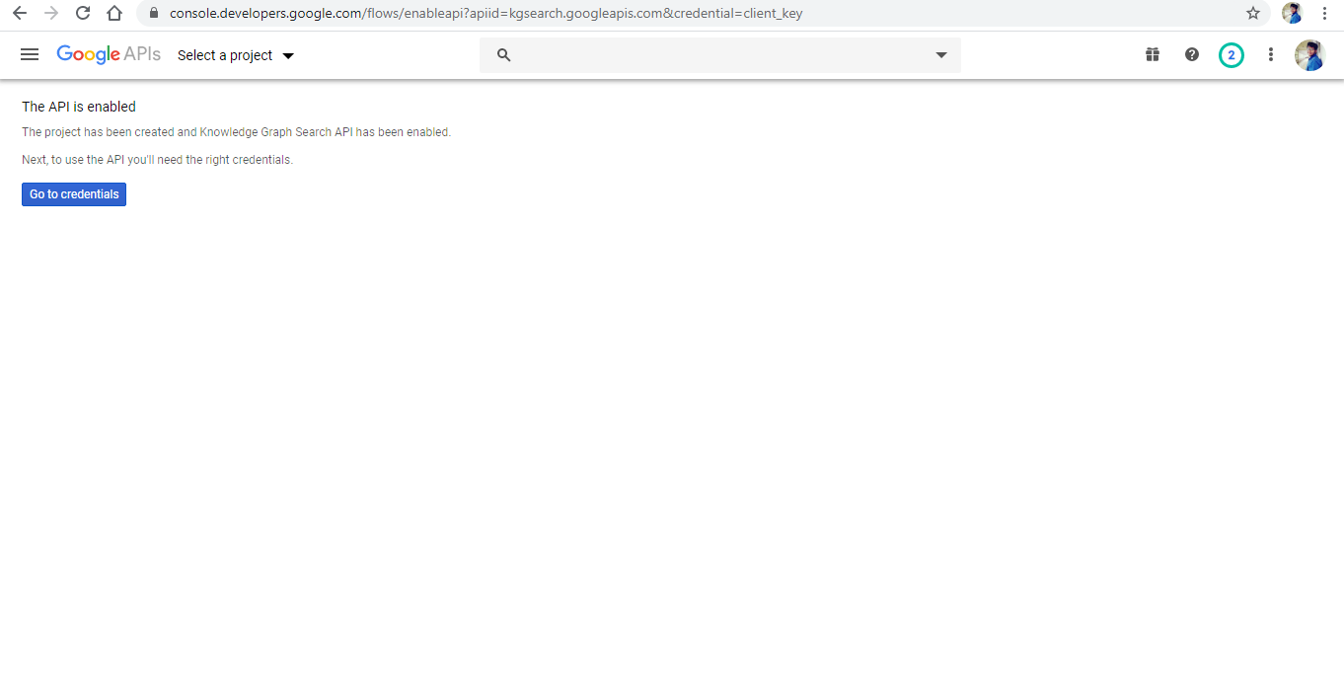

1. **Click on What Credentials do I Need?**

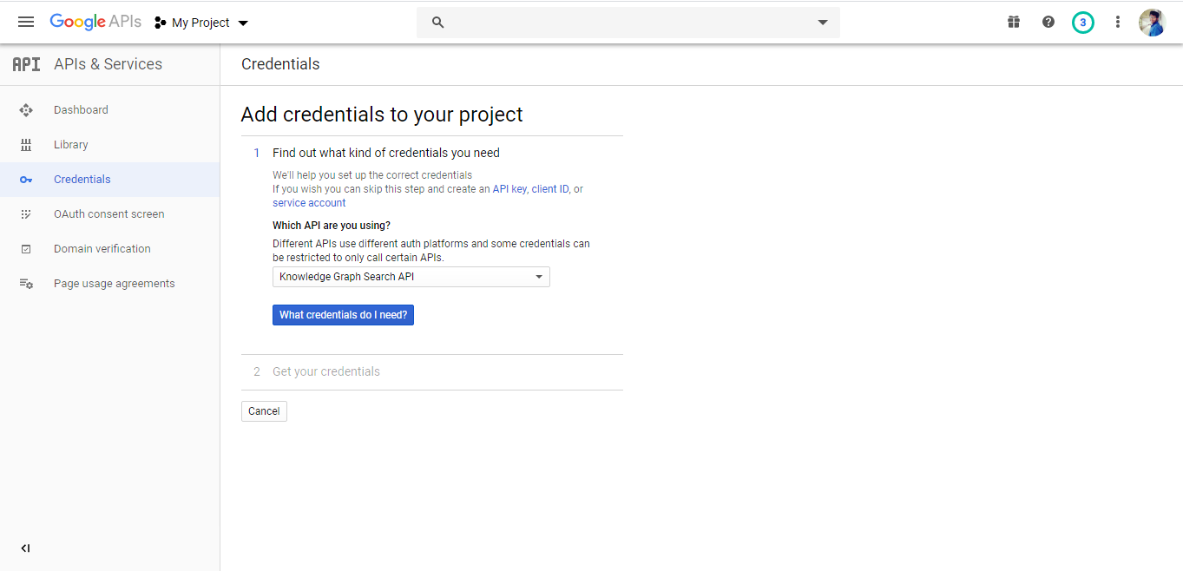

1. **Credentials (API Key) for your project is created.**

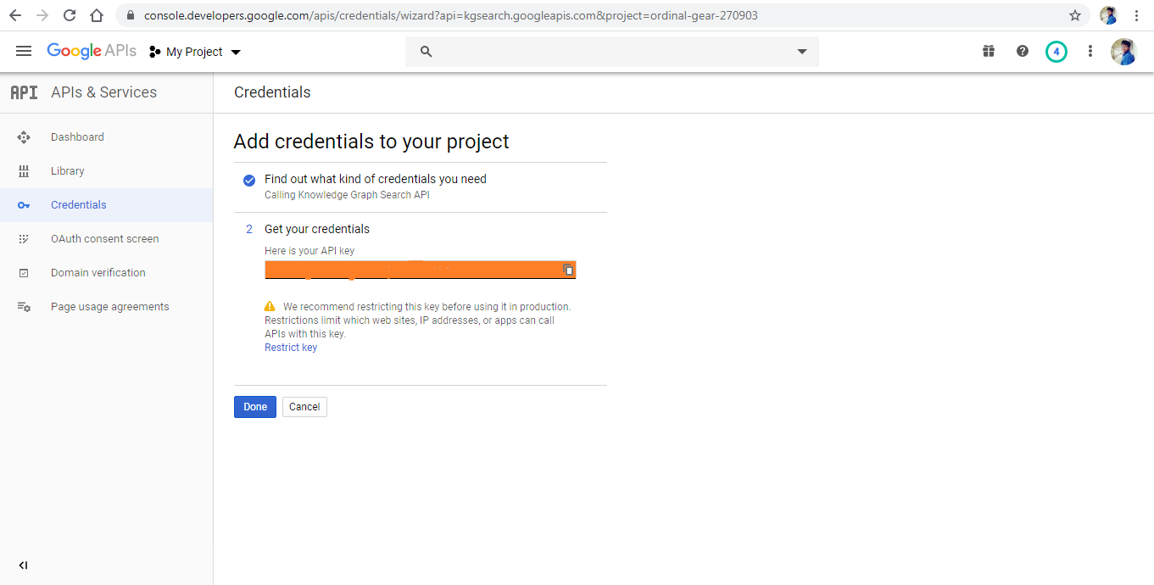

**Workflow:**

**Code: Structure of an Application**

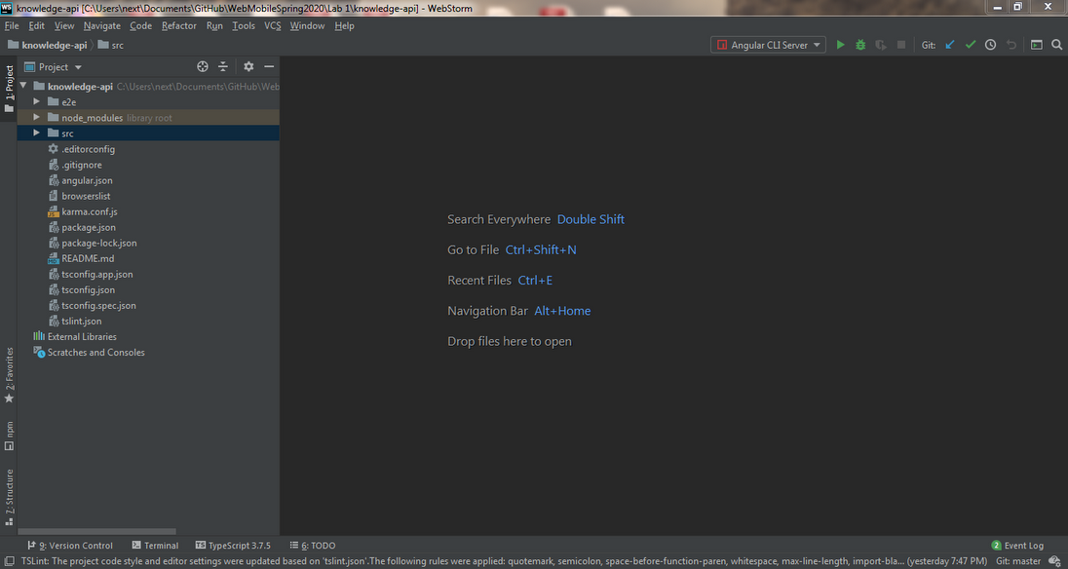

**Structure of a component in an Application**

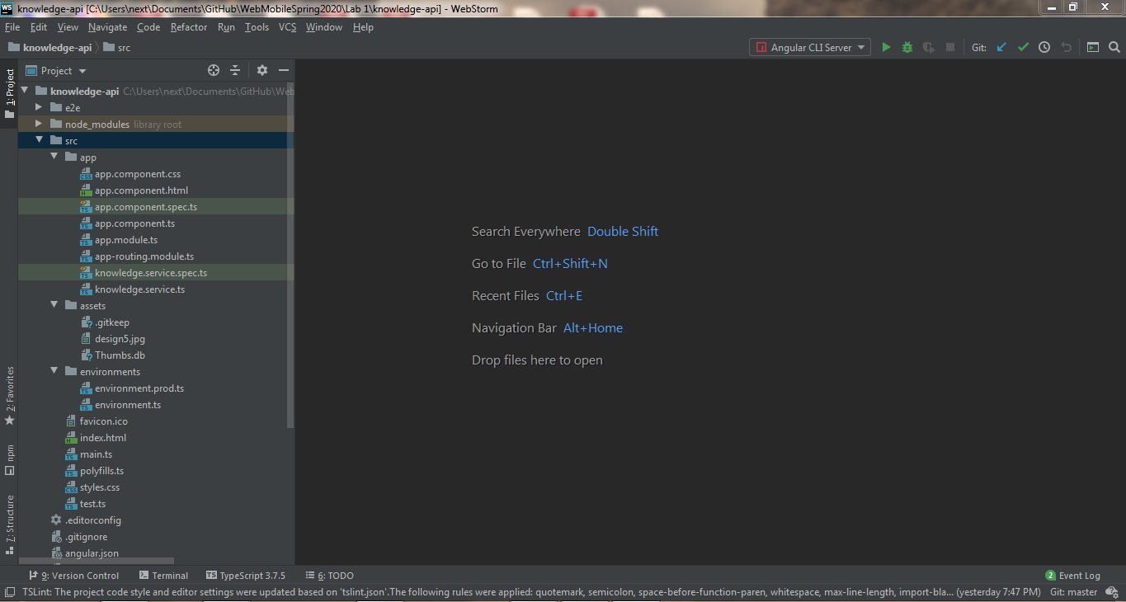

**app.component.css file**

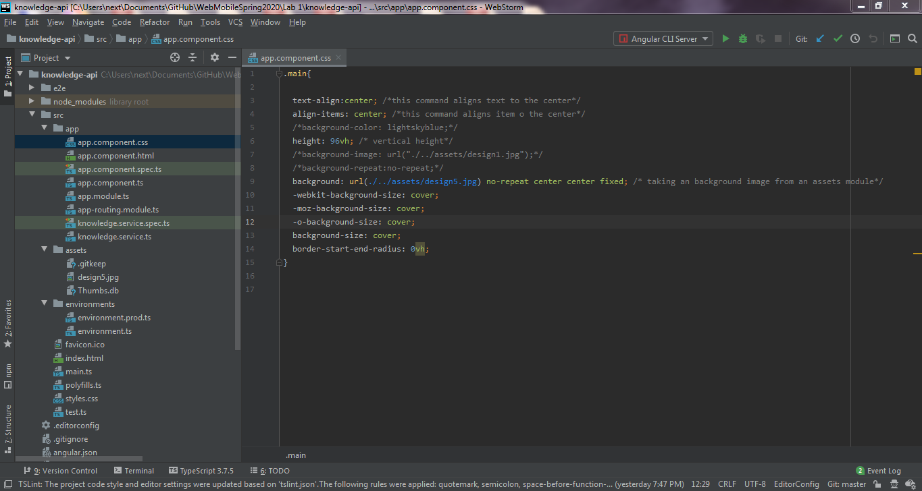

**app.component.html file**

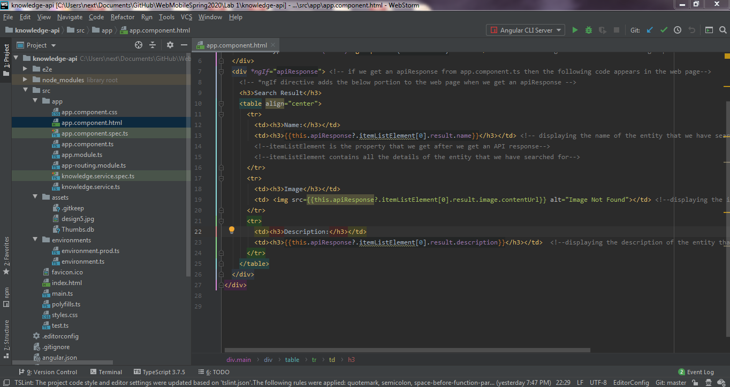

**app.component.ts file**

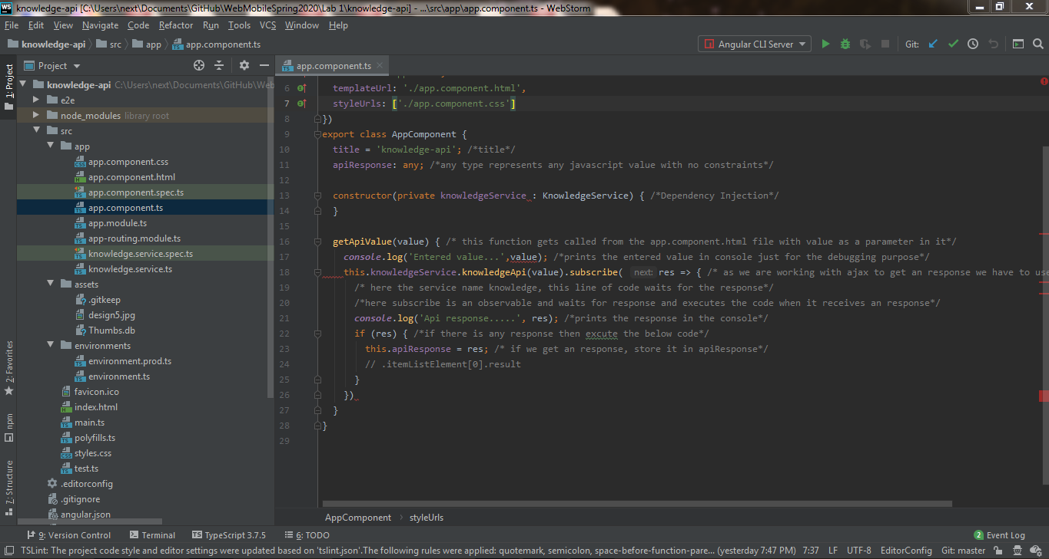

**app.module.ts**

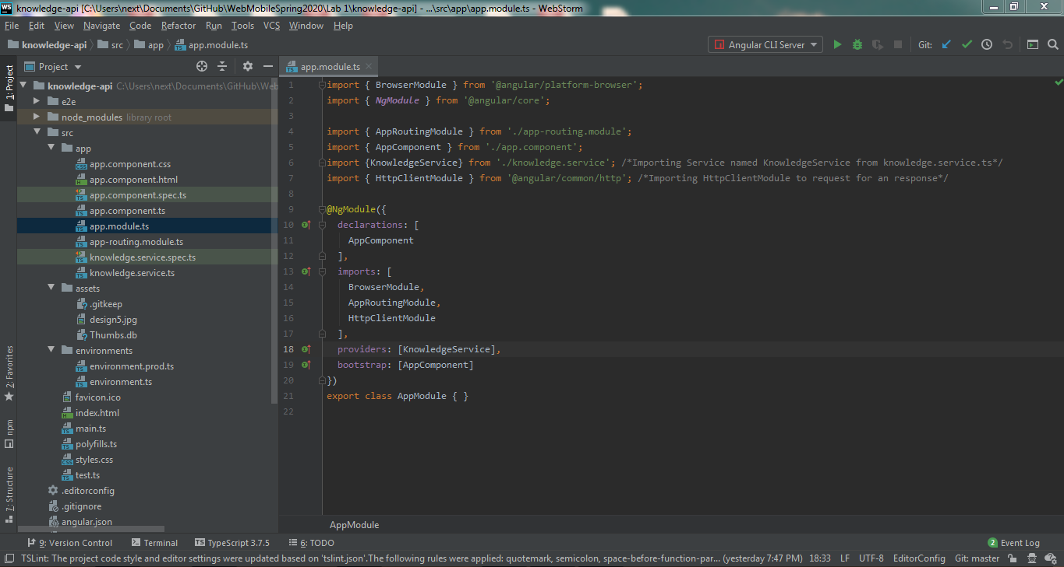

**knowledge.service.ts**

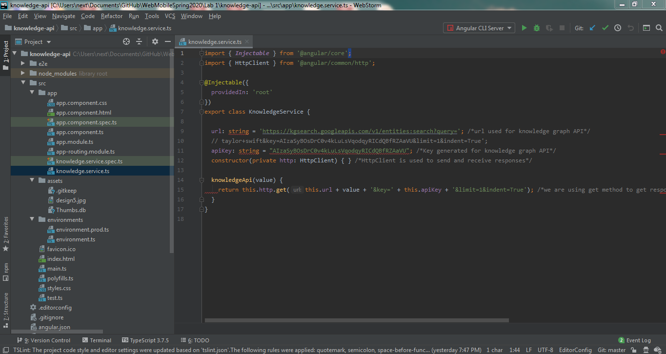

**design5.jpg file**

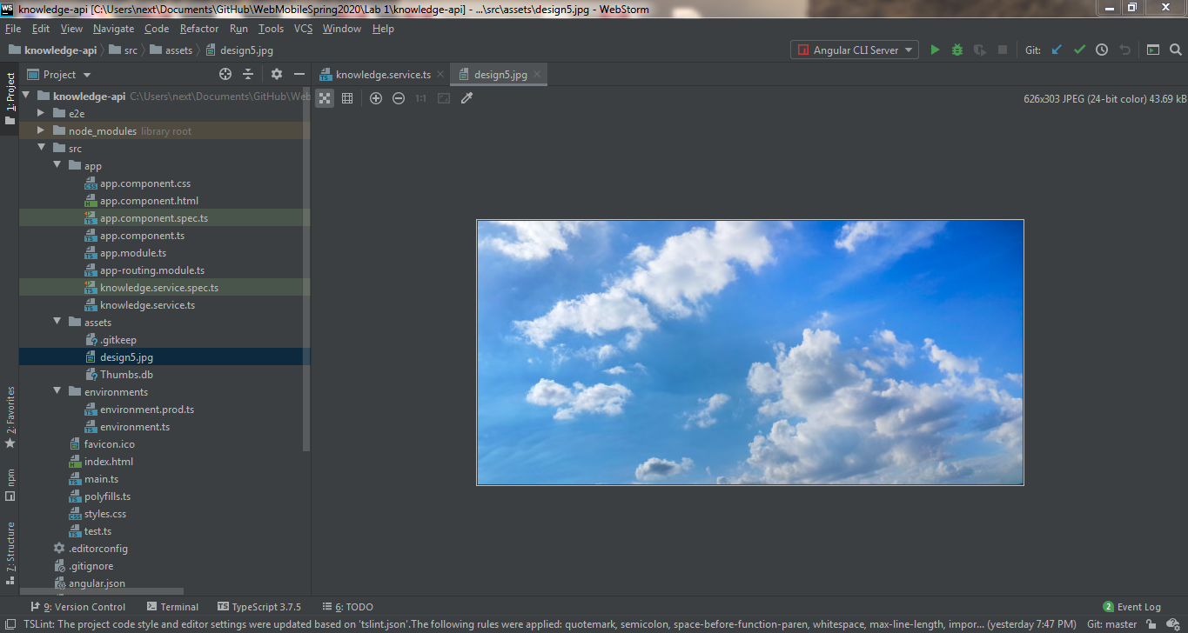

**index.html file**

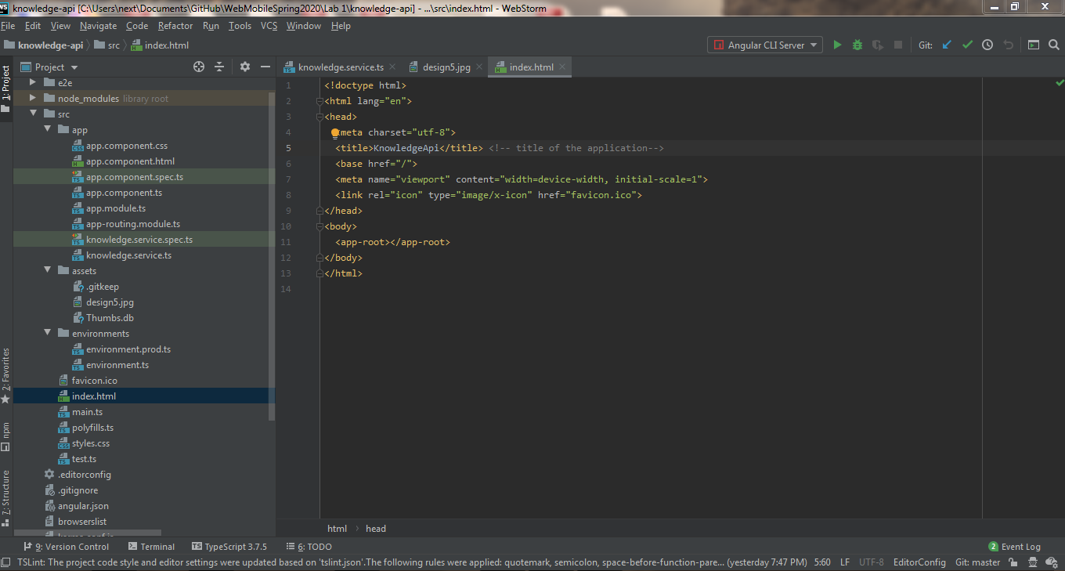

**Output:**

**Output is available in port Number 4200**

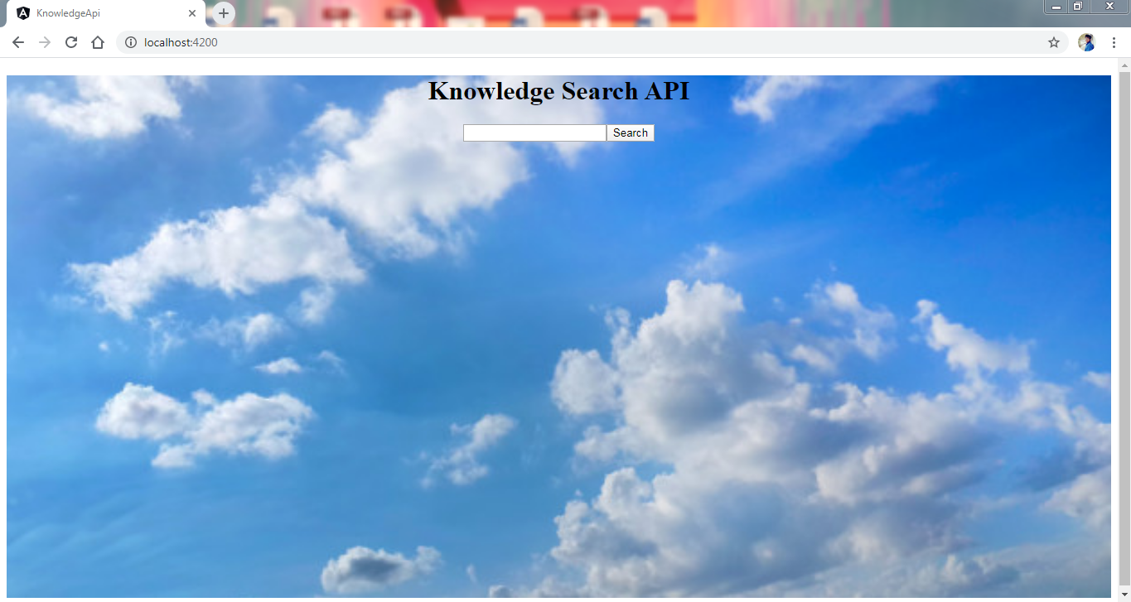

**Enter the entity value. (Person)**

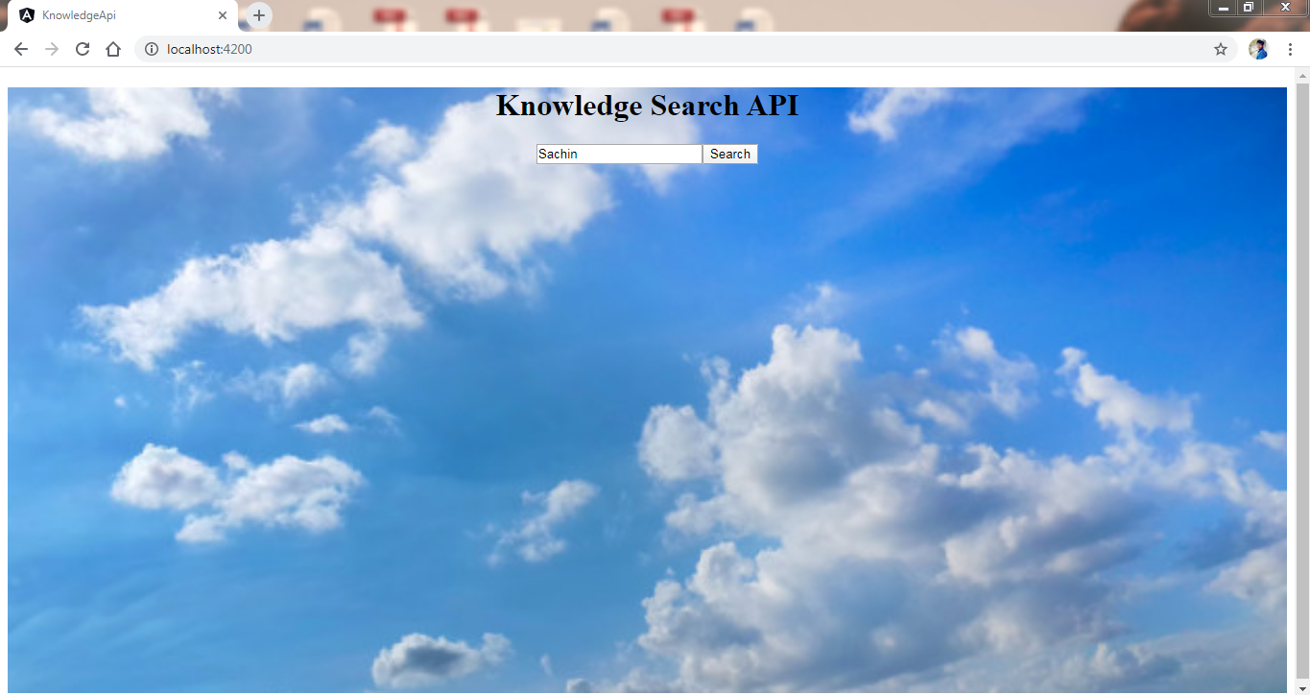

**After receiving an response the entity details have been displayed in the below format**

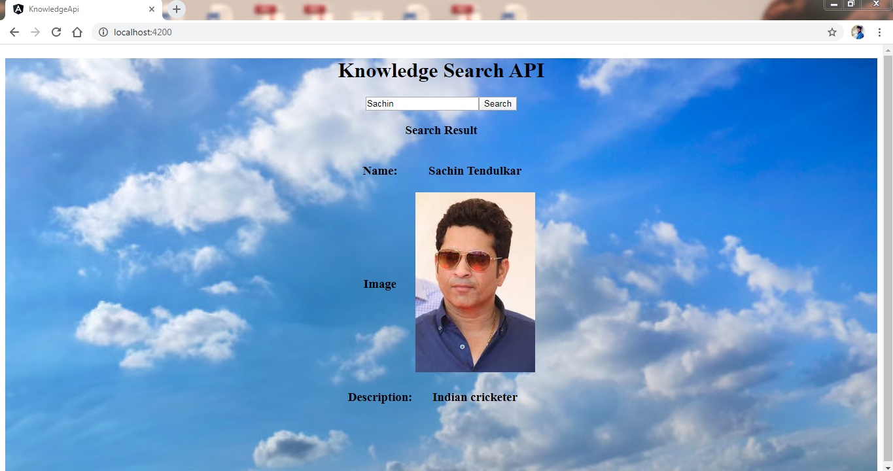

**Enter the entity value. (Sport/thing)**

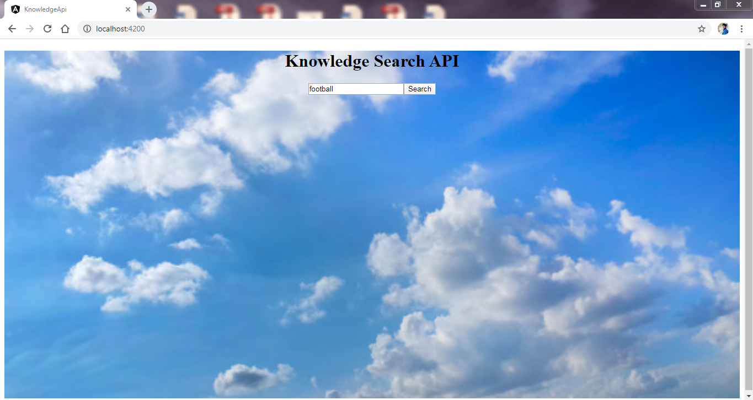

**After receiving an response the entity details have been displayed in the below format**

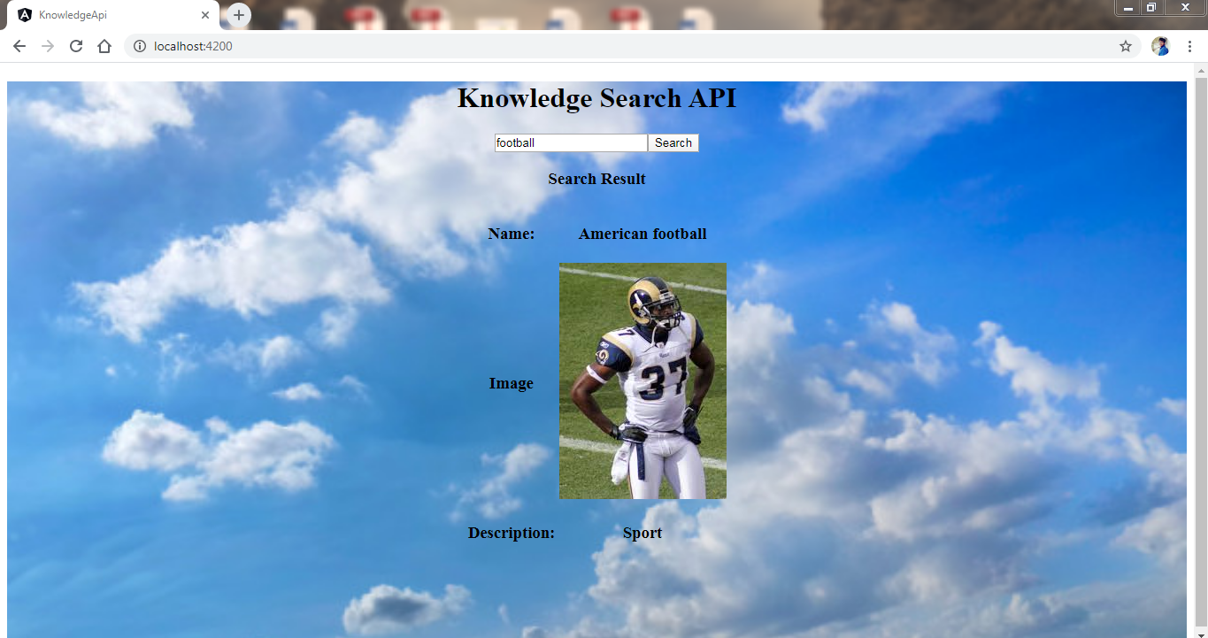

**We can even check the traffic, errors and median latency of an API’s and Services**

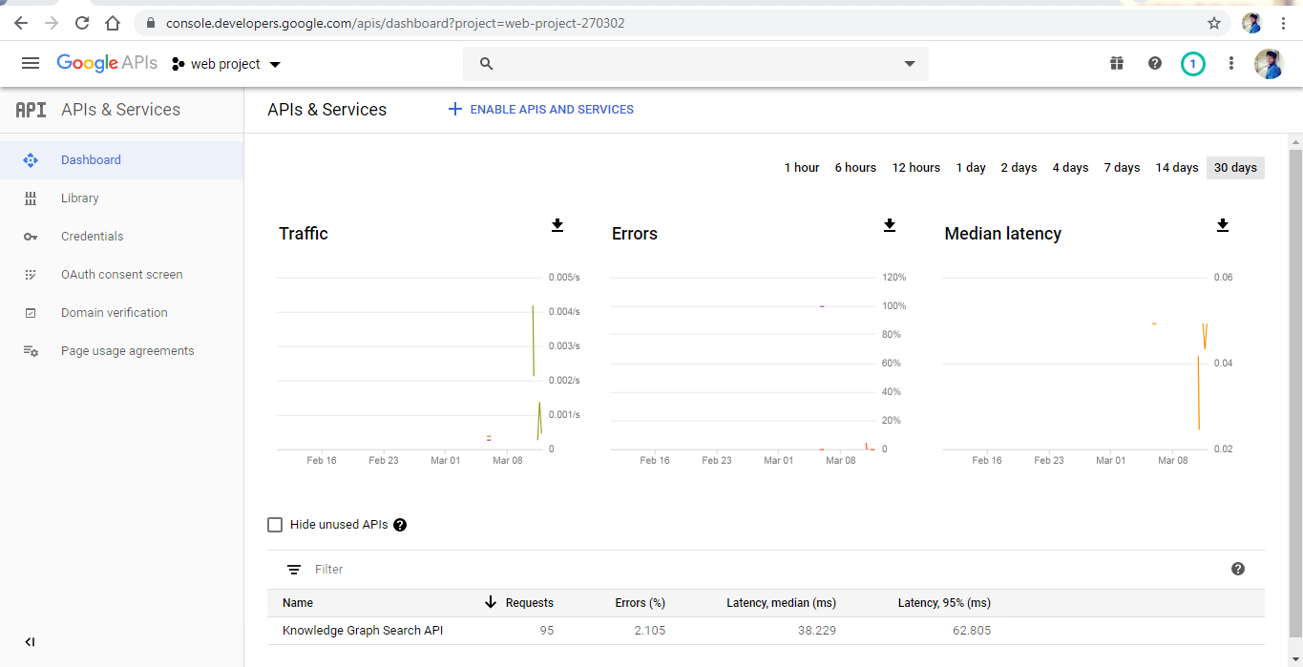

**Conclusion**

We have created an application that takes a value and returns us an entity with its image and description with the help of Google Knowledge Graph Search API.

**References**

**Google Knowledge Graph Search API**

<https://kgsearch.googleapis.com/v1/entities:search?query=taylor+swift&key=API_KEY&limit=1&indent=True>

**Reference Link**: https://developers.google.com/knowledge-graph/